**Index**

**Black Box Testing**

**Type of the Black Box Testing Technique**

1. **Functional Testing**

**Few Major Type of Functional Testing are**

* Smoke Testing
* Sanity Testing
* Integration Testing
* System Testing
* Regression Testing
* User Acceptance Testing

1. **Non-Functional Testing**

**Few major types of Non-functional testing include:**

* Usability Testing
* Load Testing
* Performance Testing
* Compatibility Testing
* Stress Testing
* Scalability Testing

1. **Black Box Testing Technique**

* Equivalence Partitioning
* Boundary Value Analysis
* Decision Table Testing
* State Transition Testing
* Error Guessing
* Graph-Based Testing Methods
* Comparison Testing

**White Box Testing**

**Type of White Box Testing**

Code Coverage

Segment Coverage

Branch Coverage and Node Coverage

Compound Condition Coverage

Basis Path Testing

Data Flow Testing

Path Testing

Loop Testing

**Techniques of White Box Testing**

Unit Testing, Integration Testing, Execution Testing, Statement, Branch Coverage and Path Coverage

**Functional Testing**

**Non-Functional Testing**

**Black Box Testing Technique**

**1) Equivalence Partitioning:** The Tweet length must not Exceed 280 Character. This 280 character contain Text, Tweet handle and Special Word.

|  |  |  |  |  |  |  |  |  |  |  |
| --- | --- | --- | --- | --- | --- | --- | --- | --- | --- | --- |
|  |  |  |  |  |  |  |  |  |  |  |
|  | **Tweet Length** |  |  |  | **Accept Tweet Length from 1 character to 280 character** | | | | | |
|  |  |  |  |  |  |  |  |  |  |  |
|  |  | **Equivalance Class Partition** | | |  |  |  |  |  |  |
|  |  | Invalid | Valid | Invalid |  |  |  |  |  |  |
|  |  | **<=0** | **1-280** | **>280** |  |  |  |  |  |  |
|  |  |  |  |  |  |  |  |  |  |  |

#### 2) Boundary Value Analysis:

#### No such Analysis Exist

#### Decision Table Testing

|  |  |  |  |  |  |
| --- | --- | --- | --- | --- | --- |
| **Decision Table/ Cause-Effect** | | | | | |
|
| **Decision Table** | **Accept User** | **Reject User** | **Accept user Tweet** | **Reject User Tweet** |  |
| **Conditions** |  | | | |  |
| **Valid User Credential** | **T** | **F** | **F** | **F** |  |
| **Invalid User Credential** | **F** | **T** | **F** | **T** |  |
| **Valid Tweet Length** | **T** | **F** | **T** | **F** |  |
| **Invalid Tweet Length** | **T** | **F** | **F** | **T** |  |

1. **State Transition Testing**

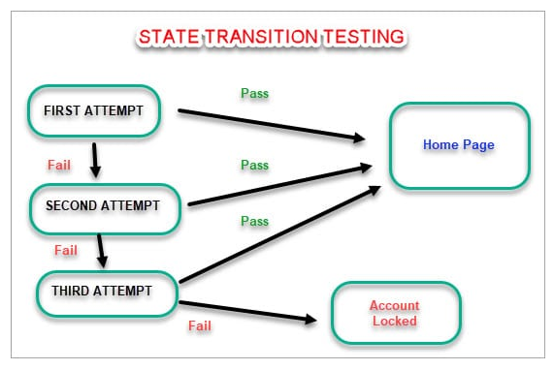

White Box Testing

**Main White Box Testing Techniques:**

1. **Statement Coverage:** Each Statement is executed at least once.
2. **Branch Coverage:** All Branch are tested
3. **Path Coverage:** All the path of the program traversed at least once.

Flow Chart

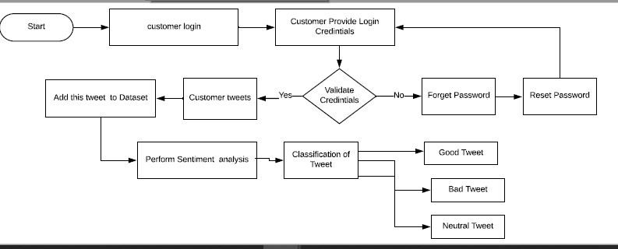

**Functional Testing**

1. **Sanity Testing:** All the Major Vital functionality that include allow person to place tweet, storage of Tweet in Dataset and Tweet classification is tested.
2. **Smoke Testing:** This is first version of the software produced. So, Smoke Testing is performed once for version 1.0.
3. **Regression Testing:** It is thoroughly performed. Any change in code enhancement and fixing the bug is not affecting software.
4. **Integration Testing:** The module for validating the Customer Credential, allowing the person to place tweet, Storage of Tweet in Dataset and Tweet classification is tested.
5. **Beta / Usability Testing:** This is not performed yet.
6. **System / End to End Testing:** Complete System is verified once all the module is integrated in integration testing.